Training, Evaluating, and Comparing Six Large Language Models for Perplexity

William Snider Dominican University
July 7, 2026 River Forest, IL

Abstract
The objective of this study was to fine tune, either partially or fully, several pretrained decoder-only Transformer large language models so that they could achieve reasonable perplexity scores on three classic text datasets. Additionally, the study evaluates how varying parameter counts affects perplexity outcomes. In this study, six models were fine-tuned, evaluated, and compared. Three classic text datasets, including DailyDialog, Blended Skill Talk, and Dolly 15k, were used to train and evaluate the models. At Google Colab Pro, the Python programming language was used in Jupyter Notebooks. The original datasets were all split into training, validation, and test sets. The following is a list of the six models and their evaluation perplexity scores: DistilGPT-2: 11.5 (validation PPL), GPT-2 Small: 3.87 (test PPL), GPT2-Medium: 26.5 (test PPL), OPT-350M: 24.96 (validation PPL), GPT-2 Large: 3.27 (test PPL), Pythia-1B: 8.1 (test PPL). In this study, six pretrained Transformer models were fine-tuned, and they all were shown to offer reasonable perplexity scores across these text datasets. All of these Transformer models were effective at predicting the next token. The results of this study suggest that extensive training is not required for reliable perplexity performance. Additionally, the results demonstrate that structural rigor of datasets is the primary determinant of perplexity. Furthermore, the study suggests that the higher structural rigor of datasets systematically lowers perplexity across models. A deep learning researcher should understand that greater dataset rigor provides more accurate next-token prediction.

Introduction
The goal of this study is to train, evaluate, and compare several off-the-shelf decoder-only Transformer models. This evaluation of multiple large language models matters because it reveals how differences in model scale, training data, and architectural design affect performance on language tasks. The study intends to obtain reasonable perplexity scores across all models and provide empirical insight into practical large language model fine-tuning.

Together the datasets provide three different types of text that allow the models to be evaluated under distinct language conditions. DailyDialog provides brief conversational exchanges (Microsoft, 2026). Blended Skill Talk offers varied and informal dialog. Dolly 15k supplies instruction and response pairs.

A large language model is a neural network trained on extensive text corpora to learn statistical patterns in human language. After training, it can answer questions, generate explanations, summarize information, and create new text that is similar to human writing. Its core function is next-word prediction. Training on large and diverse datasets allows it to execute a wide range of language tasks without task-specific programming.

Self-attention is the core mechanism in the processing architecture utilized by all six of the models. The author stated, “Self-attention, sometimes called intra-attention is an attention mechanism relating different positions of a single sequence in order to compute a representation of the sequence. Self-attention has been used successfully in a variety of tasks including reading comprehension, abstractive summarization, textual entailment and learning task-independent sentence representations” (Vaswani et al., p. 2, 2017).

Methods

The study used three classic text datasets: DailyDialog, Blended Skill Talk, and Dolly 15k. All three of these are conversational datasets. Each was split into training, validation, and test subsets. DailyDialog contains 13,118 dialogues. Using an approximately 80/7/7 split, it was partitioned into 11,118 training dialogues, 1,000 validation dialogues, and 1,000 test dialogues. An example DailyDialog conversation is shown in Figure 1 (Li et al., p. 1, 2017). The author stated, “It covers ten categories ranging from ordinary life to financial topics, which is different from domain-specific datasets” (Li et al., p. 3, 2017). Blended Skill Talk contains 6,502 dialogue examples. It was divided into 5,202 training dialogues and 1,300 validation dialogues using an 80/20 split. An example Blended Skill Talk conversation is shown in Figure 2 (Smith et al., p. 4, 2020). The author stated, “We compared the performance of these schemes on BlendedSkillTalk, a new English-language dataset blending three conversation skills in balanced proportions (demonstrating knowledge, empathy, or ability to talk about oneself)” (Smith et al., p. 9, 2020). Dolly 15k contains 15,000 instruction–response examples. Using an 80/10/10 split, it was partitioned into 12,000 training examples, 1,500 validation examples, and 1,500 test examples. Each Dolly-15k item uses the same format: an instruction, optional context, a response, and a task category. An example Dolly 15k sample is shown in Figure 3.

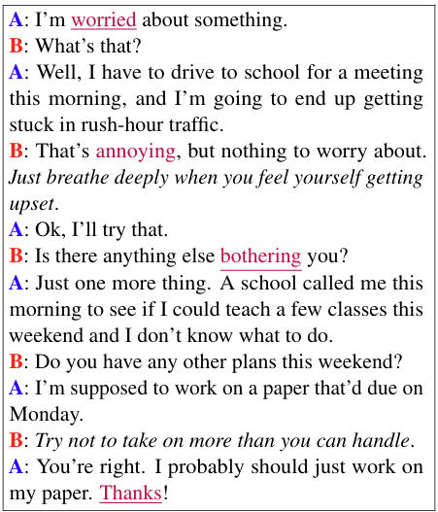
Figure 1 (DailyDialog)

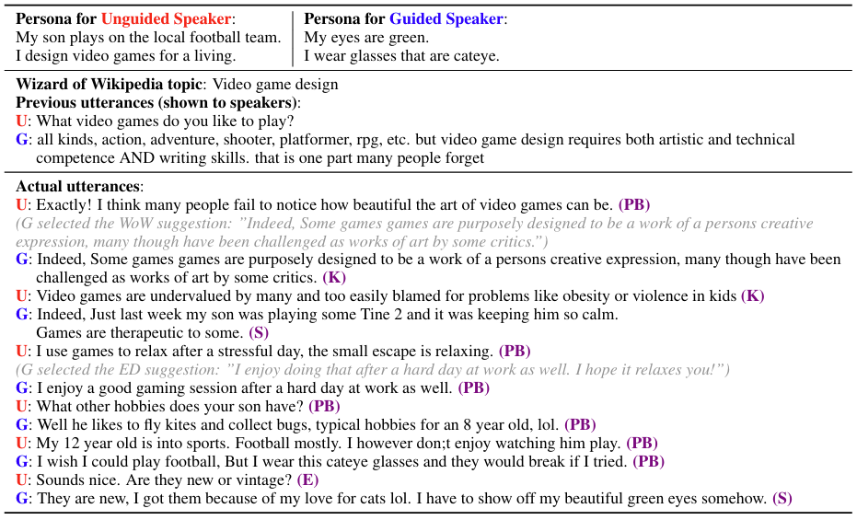Figure 2 (Blended Skill Talk)

{'instruction': 'When did Virgin Australia start operating?',
'context': "Virgin Australia, the trading name of Virgin Australia Airlines Pty Ltd, is an Australian-based airline. It is the largest airline by fleet size to use the Virgin brand. It commenced services on 31 August 2000 as Virgin Blue, with two aircraft on a single route. It suddenly found itself as a major airline in Australia's domestic market after the collapse of Ansett Australia in September 2001. The airline has since grown to directly serve 32 cities in Australia, from hubs in Brisbane, Melbourne and Sydney.",
'response': 'Virgin Australia commenced services on 31 August 2000 as Virgin Blue, with two aircraft on a single route.',
'category': 'closed_qa'}
Figure 3 (Dolly 15k)

Prior to tokenization, all datasets were standardized into a single text field. DailyDialog dialogues were flattened into continuous text sequences. Blended Skill Talk examples were created by joining together the free-form or guided messages in each dialogue. In order to maintain consistency across the dataset, Dolly 15k entries were reformatted into a unified Instruction–Context–Response structure.

Utilizing each model’s pretrained tokenizer, the text was tokenized. The sequences were shortened to fixed lengths. For DailyDialog and BST, 128 tokens were used. For Dolly 15k, 256 tokens were used. Each sequence was padded up to its full length. The padding tokens were masked in the labels so that they would not influence the loss.

Six pretrained decoder-only Transformer models were fine-tuned: DistilGPT-2 (82M parameters), GPT-2 Small (124M), GPT-2 Medium (345M), OPT-350M, GPT-2 Large (774M), and Pythia-1B (see Figure 4). All training was done at Google Colab Pro. In the lab, Nvidia T4 GPUs were used for faster training of the models. The number of training epochs performed on each model was three. After training was completed, evaluation of the models was done on their respective evaluation sets.
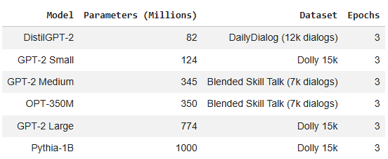
Figure 4

All models were trained utilizing the AdamW optimizer. The learning rates were between 2e-5 and 2e-4. The batch sizes ranged from 1 to 4. For Pythia-1B, gradient accumulation was employed to produce an effective batch size of 8.

DistilGPT-2 and GPT-2 Small were trained utilizing full-precision PyTorch loops. Given the GPU restrictions in Google Colab Pro, parameter-efficient fine-tuning was utilized on four of the models. GPT-2 Medium and OPT-350M were trained using 8-bit quantization. During fine tuning, LoRA adapters were applied to their attention projection layers. GPT-2 Large utilized 4-bit NF4 quantization with LoRA applied to both c_attn and c_proj. LoRA-based fine-tuning was performed on Pythia-1B using the TRL SFTTrainer framework.

Whenever the model and its quantization setup allowed it, all models utilized mixed-precision training (fp16 or bf16). At the end of each epoch, validation loss was calculated for all models. This was performed using either Hugging Face’s Trainer/SFTTrainer or custom PyTorch evaluation loops.

Model performance was measured using perplexity. It was computed by exponentiating the average cross-entropy loss over the validation or test split. Across all six models, these evaluation procedures produced comparable measures of next-token prediction performance.

Results
The following is a list of the six models and their evaluation perplexity scores.
DistilGPT-2: 11.5 (validation PPL)
GPT-2 Small: 3.87 (test PPL)
GPT2-Medium: 26.5 (test PPL)
OPT-350M: 24.96 (validation PPL)
GPT-2 Large: 3.27 (test PPL)
Pythia-1B: 8.1 (test PPL)

Figure 5 provides a visual presentation of these validation and test perplexity scores.

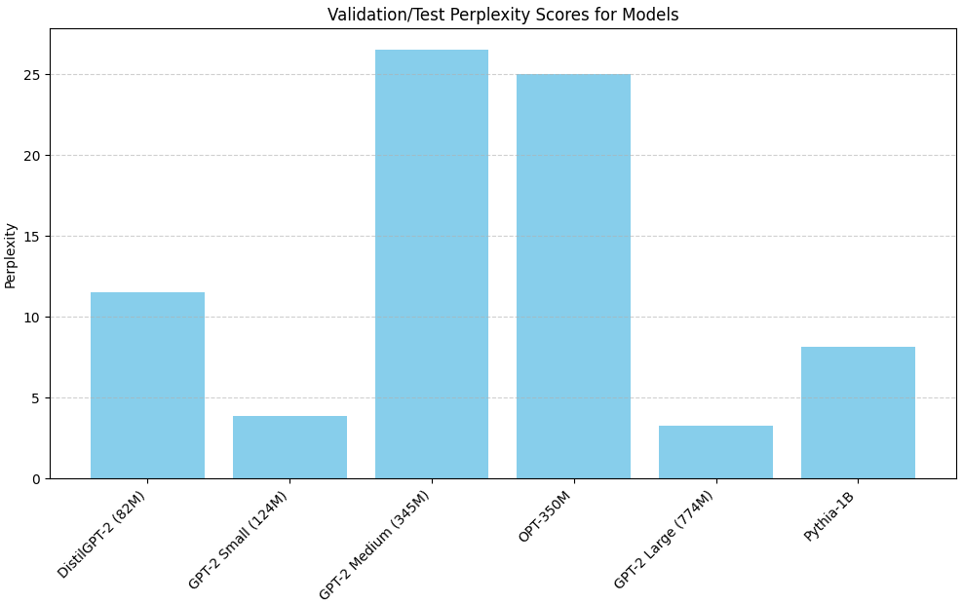Figure 5

Discussion
The findings suggest that dataset structure is the strongest influence on perplexity. More structured datasets consistently produce lower perplexity across all model sizes. This indicates that dataset rigor has a greater influence on perplexity behavior than model scale. When the dataset provides stronger structural cues, the model becomes less uncertain about the next token, which lowers perplexity. The model trained on DailyDialog, which is the most structured dataset, achieves substantially lower perplexity, even though the model is relatively small. Models trained on Blended Skill Talk, which is the least structured dataset, show much higher perplexity, even though the model is relatively large. Models trained on Dolly 15k, which has a moderate level of structural rigor, achieve relatively low perplexity.

Given this importance of dataset rigor, one should take seriously the task of choosing and designing a dataset. Careful consideration should be given to dataset features. Thoughtfulness and creativity should be used when designing datasets of the future. These two tools are used by Li et al. The author stated, “In addition, DailyDialog contains unique multi-turn dialog flow patterns, which reflect our realistic communication ways. And it is rich in emotion” (Li et al., p. 9, 2017).

The study was limited by the amount of available compute. For one thing, this constrained model size. Additionally, none of the outputs were judged by humans. Thus, the study did not assess correctness, relevance, coherence, or fluency. All conclusions depend solely on perplexity, which reflects next-token prediction accuracy instead of the overall quality of the generated text.

Future research should include evaluating 3B to 100B-scale models. This would offer an improved understanding of how perplexity trends extend to bigger architectures. Additionally, larger training datasets should be experimented with. The author stated, “We find that current large language models are significantly undertrained, a consequence of the recent focus on scaling language models whilst keeping the amount of training data constant” (Hoffman et al., p. 1, 2022). Furthermore, higher quality datasets should be experimented with. The author stated, “Speculatively, we expect that scaling to larger and larger datasets is only beneficial when the data is high-quality. This calls for responsibly collecting larger datasets with a high focus on dataset quality” (Hoffman et al., p. 16, 2022).

Conclusion

In this study, fine-tuning six off-the-shelf large language models generated a range of reasonable perplexity scores. This shows reliable performance across model sizes and datasets without requiring extensive training.

One hypothesis from this study is that dataset structure matters more than model size when measuring perplexity. When considering Figure 2, it appears that what matters the most is the dataset structure. As structural rigor of the dataset rises, perplexity scores decrease. High-rigor datasets are inherently more predictable, and that predictability is what lowers perplexity. When a dataset’s structural rigor furnishes uniform cues which narrow the model’s next-token expectations, perplexity declines. When rigor is low, those cues disappear, uncertainty expands, and perplexity rises.

DailyDialog shows moderate rigor with concise two-speaker interactions, which provide limited structural cues. Blended Skill Talk exhibits low rigor because its mixed, multi-turn conversations create high entropy and inconsistent phrasing. Dolly-15k has high rigor with its stable instruction–context–response format, which offers a consistently repeatable structure.

This study provides empirical insight into large language model behavior and establishes a baseline for future research on efficient fine-tuning and evaluation within the natural language processing field.

References

Hoffmann, J., Borgeaud, S., Mensch, A., Buchatskaya, E., Cai, T., Rutherford, E., de Las Casas, D., Hendricks, L. A., Welbl, J., Clark, A., Hennigan, T., Noland, E., Millican, K., van den Driessche, G., Damoc, B., Guy, A., Osindero, S., Simonyan, K., Elsen, E., Rae, J. W., Vinyals, O., & Sifre, L. (2022). Training compute-optimal large language models. DeepMind. https://arxiv.org/abs/2203.15556

Li, Y., Su, H., Shen, X., Li, W., Cao, Z., & Niu, S. (2017). DailyDialog: A manually labelled multi-turn dialogue dataset. Proceedings of the 8th International Joint Conference on Natural Language Processing (IJCNLP 2017). arXiv. https://doi.org/10.48550/arXiv.1710.03957
Microsoft Copilot. (2026). https://copilot.microsoft.com/

Smith, E. M., Williamson, M., Shuster, K., Weston, J., & Boureau, Y.-L. (2020). Can You Put it All Together: Evaluating Conversational Agents by Disentangling Skills. Proceedings of the 2020 Conference on Empirical Methods in Natural Language Processing (EMNLP). https://arxiv.org/pdf/2004.08449v1
Vaswani, A, Shazeer, N., Parmar, N., Uszkoreit, J., Jones, L., Gomez, A. N., Kaiser, L., & Polosukhin, I. (2017). Attention is All You Need. In Advances in Neural Information Processing Systems (pp. 5998–6008). https://arxiv.org/pdf/1706.03762

